📊 Healthcare Data Analytics Dashboard

🌟 Project Overview
This project presents a complete Healthcare Data Analytics Dashboard built using Microsoft Excel, covering data cleaning, transformation, analysis, pivot tables, Quick Analysis insights, and dashboard creation.
All three datasets were combined into a unified Healthcare sheet using XLOOKUP and data modeling.
📅 Date: 25 Nov 2025
👩‍💻 Author: Indhira S — Aspiring Data Analyst

📌 Dashboard Preview
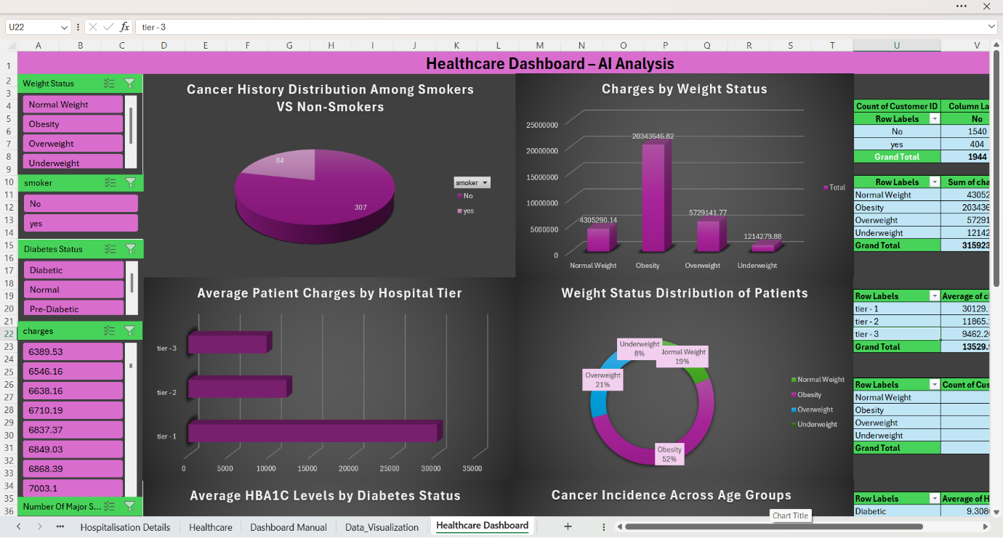

🗃️ Dataset Fields
Field | Description
🆔 Customer ID | Unique identifier
👤 First Name | Patient’s name
⚖️ BMI | Body Mass Index
🩸 HBA1C | Glucose level indicator
❤️ Heart Issues | Yes/No
🏥 Any Transplants | Yes/No
🎗️ Cancer History | Yes/No
🔪 Major Surgeries | Number of surgeries
🚬 Smoker | Yes/No
⚖️ Weight Status | Underweight/Normal/Overweight/Obesity
🩺 Diabetes Status | Diabetic / Pre-Diabetic / Normal
🎂 Date of Birth | Cleaned and formatted DOB
💵 Charges | Hospitalization costs
🏥 Hospital Tier | Tier-1 / Tier-2 / Tier-3
🌆 City Tier | Tier classification
🆔 State ID | State-level identifier
🎯 Age | Calculated age (as of 8 June 2023)

🧹 Data Cleaning Steps
✔️ Replaced '?' missing values
✔️ Filled missing month with September
✔️ Replaced missing Year with rounded average
✔️ Filled missing Smoker, City Tier, Hospital Tier using Mode()
✔️ Missing State ID → filled with "Unknown"
✔️ Cleaned Number Of Major Surgeries → converted to numeric
✔️ Split Name → Title, First Name, Last Name
✔️ Merged Year + Month + Date → DOB
✔️ Calculated Age using TODAY() logic
✔️ Formatted Charges column as Currency ($)

🧮 Key Formulas Used
🔧 Cleaning & Transformation
=IF(cell="?", "", cell)
=TEXT(DATE(Year, Month, Date),"DD-MMM-YYYY")
=INT((DATE(2023,6,8)-DOB)/365)
🔍 Lookup & Merge
=XLOOKUP(CustomerID, Table1[ID], Table1[Column])
📊 Weight Status (BMI Category)
=IF(BMI<18.5,"Underweight",
IF(BMI<25,"Normal Weight",
IF(BMI<30,"Overweight","Obesity")))

📊 Dashboard Insights
🔸 Cancer History: Smokers vs Non-Smokers
Smokers show higher cancer incidence, indicating lifestyle risk factors.
🔸 Charges by Weight Status
Obese patients contribute to the highest total healthcare spending.
🔸 Hospital Tier Analysis
Tier-3 hospitals show highest average charges, suggesting advanced care levels.
🔸 Diabetes & HBA1C
Higher HBA1C values correlate with diabetic patients, confirming data integrity.
🔸 Weight Status Distribution
Majority of patients fall under Obesity and Overweight categories.

🛠️ Tools Used
- Microsoft Excel
- Pivot Tables
- Pivot Charts (Pie, Doughnut, Column, Bar)
- Quick Analysis
- Slicers (Weight Status, Diabetes Status)
- Data Model + XLOOKUP

🏁 Conclusion
This Healthcare Dashboard demonstrates strong Excel analytics skills—from cleaning to visualization—providing insights for medical and operational decision-making.

💼 Connect With Me
🔗 LinkedIn (www.linkedin.com/in/indhira4623)

